SPSS Installation Instructions for Windows
Official URL: https://services.smsu.edu/TDClient/180/Portal/KB/Article/8988/SPSS-Installation-Instructions-for-Windows
Category: Knowledge Base > Information Technology Services > Software and Applications > SPSS Installation Instructions for Windows
Tags: windows, spss, spss-Installation, ibm-spss
_____________________________________________________

Overview
Follow the instructions in this article to install SPSS on Windows successfully. These steps will guide you through downloading, installing, and activating SPSS on your Windows Computer.
- Navigate to the folder sent to your email.
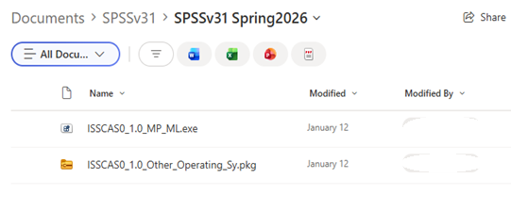
Figure 1: Screenshot of a “Documents > SPSSv31 > SPSSv31 Spring2026” folder view showing two files: “ISSCASO_1.0_MP_ML.exe” and “ISSCASO_1.0_Other_Operating_Sy.pkg,
- Click on the ‘…’ and Select “Download”
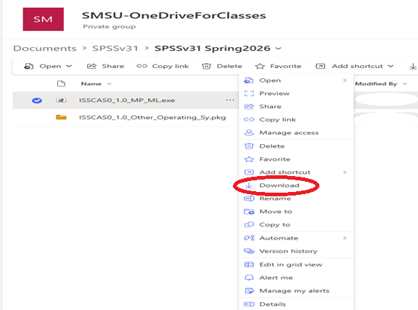
Figure 2: Screenshot of an “SMSU-OneDriveForClasses” document library (Private group) showing the folder path “Documents > SPSSv31 > SPSSv31 Spring2026.” Two files are listed: “ISSCASO_1.0_MP_ML.exe” (selected) and “ISSCASO_1.0_Other_Operating_Sy.pkg.”
- Once downloaded, click on the file and it should bring up the installation screen. Select “next”
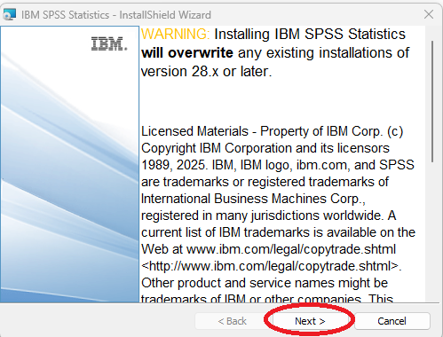
Figure 3: The window includes IBM branding, licensing text, and navigation buttons labeled Back, Next, and Cancel.
- Select “Next”
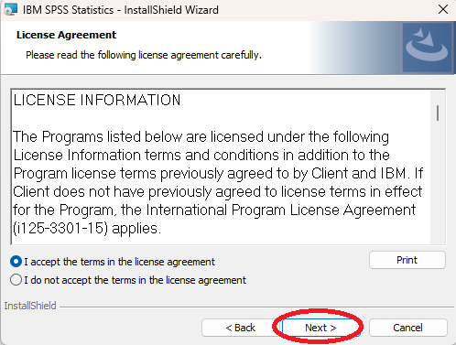
Figure 4: Screenshot of the IBM SPSS Statistics InstallShield Wizard displaying the License Agreement page. The screen shows license information text, radio button options to accept or decline the agreement, a Print button, and navigation buttons (Back, Next, Cancel).
- Select “Next”
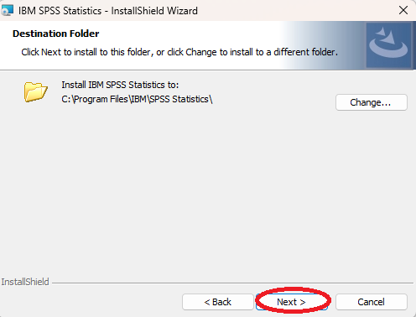
Figure 5: Screenshot of the IBM SPSS Statistics InstallShield Wizard showing the “Destination Folder” step, with the installation path set to “C:\Program Files\IBM\SPSS Statistics” and buttons for Change, Back, Next, and Cancel.
- Select “Install”
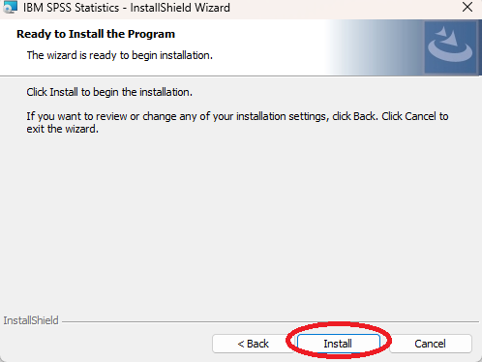
Figure 6: Screenshot of the IBM SPSS Statistics InstallShield Wizard displaying the “Ready to Install the Program” screen, with instructions to click Install to begin installation and navigation buttons labeled Back, Install, and Cancel.
- Wait for the installation to be completed
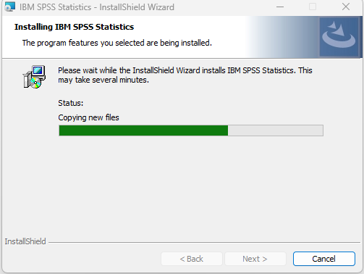
Figure 7: Screenshot of the IBM SPSS Statistics InstallShield Wizard during installation, showing a progress bar labeled “Copying new files” partially filled, with a message indicating the installation may take several minutes and a Cancel button available.
- Click on “Finish”
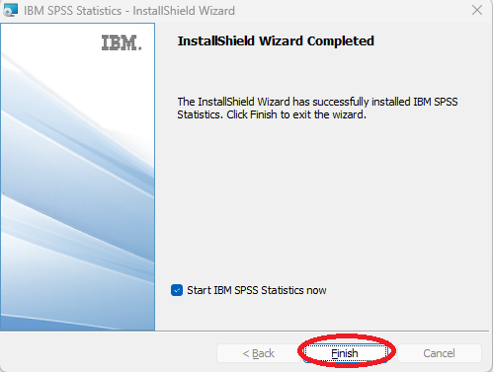
Figure 8: Screenshot of the IBM SPSS Statistics InstallShield Wizard completion screen stating “InstallShield Wizard Completed,” with a checkbox option to start IBM SPSS Statistics now and buttons labeled Back, Finish, and Cancel.
- Wait for the installation to finish and open the application once installed. Launch IBM SPSS Statistics. Select “Launch License Wizard”
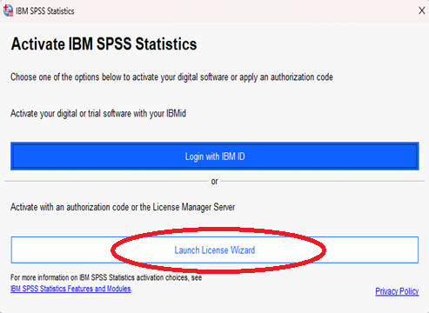
Figure 9: Screenshot of the IBM SPSS Statistics activation window titled “Activate IBM SPSS Statistics,” showing options to log in with an IBM ID or launch the License Wizard to enter an authorization code or connect to a license server.
- Select “Authorized user license. Click on ”next”
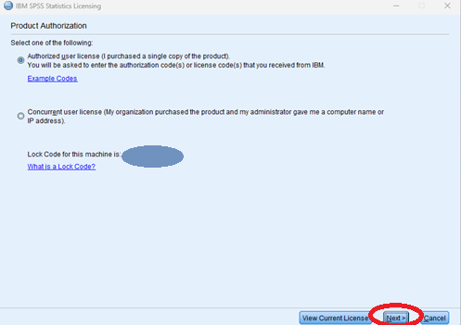
Figure 10: Screenshot of the IBM SPSS Statistics Licensing window titled “Product Authorization,” with the option “Authorized user license” selected, fields for entering authorization codes, a displayed lock code, and buttons for View Current License, Next, and Cancel.
- Enter the activation code sent to you. Select “add”. This will move the code to the bottom box. Select “Next”
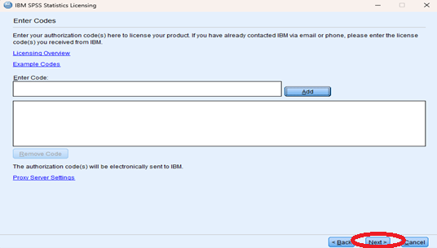
Figure 11: Screenshot of the IBM SPSS Statistics Licensing window titled “Enter Codes,” showing a text field for entering authorization codes, an “Add” button, a list box displaying a entered code, and navigation buttons labeled Back, Next, and Cancel.
- Select “Next”
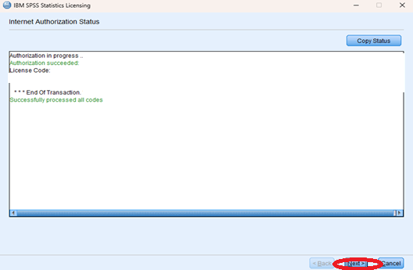
Figure 12: Screenshot of the IBM SPSS Statistics Licensing window displaying “Internet Authorization Status,” with a status message indicating authorization is in progress and successfully processed, a log area filled with text, a “Copy Status” button, and navigation buttons including Next and Cancel.
- Select “Finish”
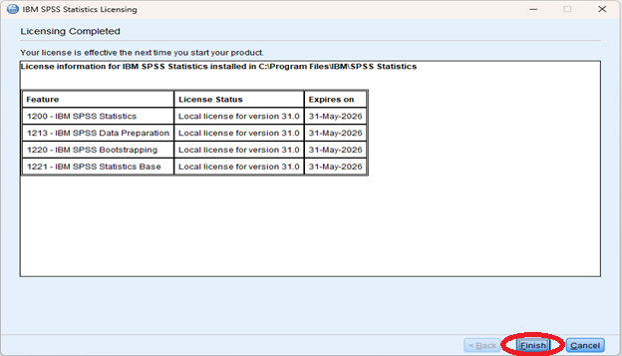
Figure 13: Screenshot of the IBM SPSS Statistics Licensing window showing “Licensing Completed.” A table lists licensed features (IBM SPSS Statistics, Data Preparation, Bootstrapping, and Statistics Base), each with a local license for version 31.0 and an expiration date of May 31, 2026. Navigation buttons Back, Finish, and Cancel appear at the bottom.
Accessibility Review & Update Log:
- [x] Content accuracy and link integrity verified
- [x] High-contrast visual hierarchy implemented (Inter and Calibri)
- [x] Image alt-text captions verified (all screenshots captioned)
- [x] Outline headers and standard list sequences optimized for screen readers

